**Course Code: CSE2067**

**Course Title: Web Technologies**

**Lab sheet 9 - Module 3**

**Problem Statement:**

Write a PHP MYSQL program to collect the student data and store in Server database.

1. Student Name, Roll_no, mail_id, mobile_no, gender, city, state and department - Minimum 4 students records to insert.
2. Display the student’s details

b. Update the student’s details

c. Delete the student Record from database.

**Step 1: run XAMPP application with MySQL**

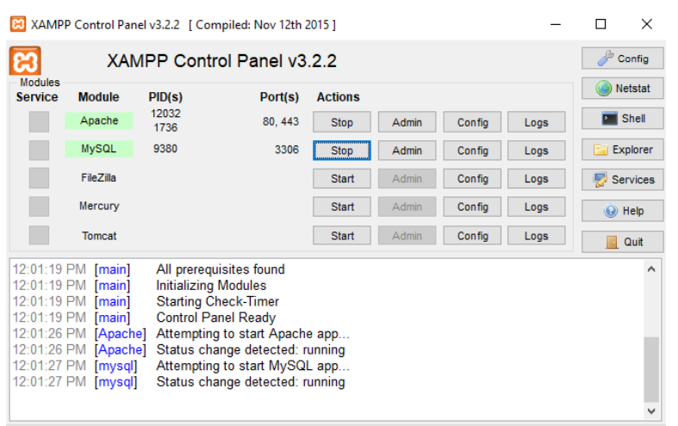

**Step 2: create a new php file filename.php and place the php file in C:/xampp / htdocs folder (accommodate required statements to establish connection with your database)**

***Registaration.html***

<!DOCTYPE html>

<html lang="en-us">

    <head> <title>Responsive Registaration Form</title></head>

    <body>

        <h1>Student Registaration Form</h1>

        <form class="srf" action="http://localhost/insertdb.php" method="post">

        <br><br>Roll No:<input type="text" id="rollno" name="rollno" >

        <br><br>Student Name:<input type="text" id="name" name="name" >

        <br><br>Email:<input type="email" id="email" name="email" >

        <br><br>Mobile:<input type="tel" id="mobile" name="mobile" >

        <br><br>Gender:<input type="radio" id="male" name="gender" value="male"/>Male

                        <input type="radio" id="female" name="gender" value="female"/>Female

        <br><br>City:<input type="text" id="city" name="city" maxlength="10">

        <br><br>State:<input type="text" id="state" name="state">

        <br><br>Specialization:<br><br>

                    <input type="checkbox" name="specialization" value="Computer Science">Computer Science<br/>

                    <input type="checkbox" name="specialization" value="Information Technology">Information Technology<br/>

                    <input type="checkbox" name="specialization" value="Computer Architecture">Computer Architecture<br/>

                    <input type="checkbox" name="specialization" value="Tele Communication">Tele Communication<br/>

        <br><br><input type="submit" value="Register" onclick="SaveStudentDetails()">

        </form>

    </body>

</html>

</body>

</html>

***insertdb.php***

<?php

$servername = "localhost";

$username = "root";

$password = "";

$dbname = "ls9_srf"; // DB Name

$v1=$_POST["rollno"]; //name attribute value

$v2=$_POST["name"];//name attribute value

$v3=$_POST["email"];//name attribute value

$v4=$_POST["mobile"];//name attribute value

$v5=$_POST["gender"];//name attribute value

$v6=$_POST["city"];//name attribute value

$v7=$_POST["state"];//name attribute value

$v8=$_POST["specialization"];//name attribute value

// Create connection

$conn = mysqli_connect($servername, $username, $password, $dbname);

// Check connection

if (!$conn)

{

  die("Connection failed: " . mysqli_connect_error());

}

$sql = "INSERT INTO srf VALUES ('$v1','$v2','$v3','$v4','$v5','$v6','$v7','$v8')";

//srf table name

if (mysqli_query($conn, $sql))

{

  echo "New record created successfully";

}

else

{

  echo "Error: " . $sql . "<br>" . mysqli_error($conn);

}

mysqli_close($conn);

?>

***updatedb.php***

<?php

$servername = "localhost";

$username = "root";

$password = "";

$dbname = "ls9_srf"; // DB Name

// Create connection

$conn = mysqli_connect($servername, $username, $password, $dbname);

// Check connection

if (!$conn) {

  die("Connection failed: " . mysqli_connect_error());

}

$sql = "UPDATE srf SET name='Arulan' WHERE Roll_No='20201CSE0004'";

if (mysqli_query($conn, $sql)) {

  echo "Record updated successfully";

} else {

  echo "Error updating record: " . mysqli_error($conn);

}

mysqli_close($conn);

?>

**Deletedb.php**

<?php

$servername = "localhost";

$username = "root";

$password = "";

$dbname = "ls9_srf"; // DB Name

// Create connection

$conn = mysqli_connect($servername, $username, $password, $dbname);

// Check connection

if (!$conn) {

  die("Connection failed: " . mysqli_connect_error());

}

$sql = "DELETE FROM srf WHERE Roll_No='20201CSE0004'";  
  
if ($conn->query($sql) === TRUE) {  
  echo "Record deleted successfully";  
} else {  
  echo "Error deleting record: " . $conn->error;  
}  
  
$conn->close();  
?>

**OUTPUT**

**Registration from**

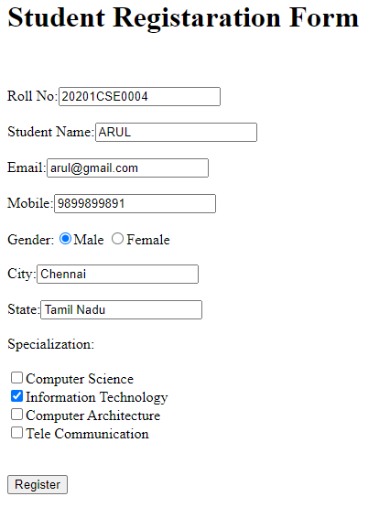

**Display student data**

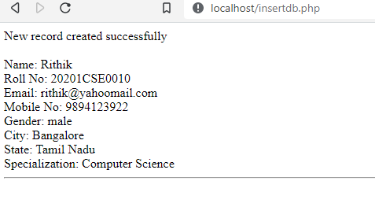

**After registration new record updated in database**



**Database table– Student registration form**

